Access control list (ACL)
===============================

An access ACL is the access control list on a specific file or directory for specific users or group members

To verify the default acl on a file/folder
==============================
# getfacl file/directoryname
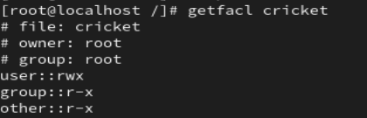

To set ACL on a file for a specific user
=============================

# setfacl -m u:username:rwx filename

# setfacl -m 'u:username:7' filename

To set ACL on a file for a specific group
=============================
# setfacl -m g:groupname:rwx filename
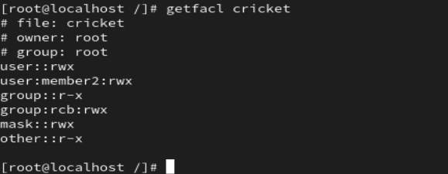
# setfacl -m g:groupname:7 filename

To remove ACL on a file for a specific user
=============================
setfacl -x u:username /secure
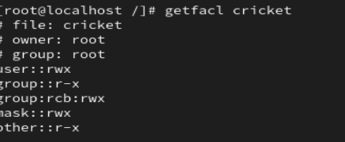

To remove ACL on a file for a specific group
=============================
setfacl -x g:username /secure
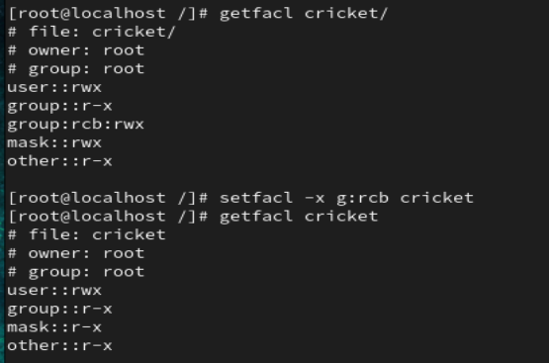

To remove all ACL
=============================

# setfacl -b file/directory #removing all ACL from file/direcoty
getfacl -R /secure

# setfacl -R -m g:groupname:rwx filename

setfacl -x u:balaji:rwx

getfacl

setfacl -b

